**Lab #0 : Writing the Laboratory Report**

Yash Jhavar

CEE300

Section AB6

TA: Aaron Dunton

August 31st 2016

**Abstract**

Tasks associated with data manipulation were performed, analyzed and a lab report was written. The data was provided by the instructor

1. **INTRODUCTION**
   1. **Stress**

Any force (F) acting per unit area (A) is defined as stress. The various types of stresses are Tensile Stress, Compressive Stress, Shear Stress. (Figure 1 depicts different types of shear forces.) Units of stress are Pascals and it is denoted using σ.

Eq. 1.1.1

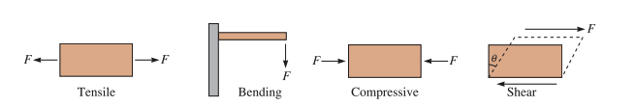

**Figure 1 : Types of Stress**

*Source: Donald R. Askeland and Pradeep P. Fulay, Essentials of Materials Science and Engineering, 2nd ed., Cengage Learning (2008),p156*.*

* 1. **Strain**

Change in length per unit length is defined as strain. Strain has no dimensions and we use -/- to express its units. The symbol used to denote strain is ε. Strain is caused due to Stress.

Eq. 1.2.1

* 1. **Elastic Strain**

A fully recoverable strain that arises from an applied stress is known as Elastic Strain. This strain occurs instantaneously after the application of force, it remains for as long as the force acts and is lost when the force is withdrawn.

A permanent deformation is not observed on objects under elastic strain. Eg. Stretching a small spring. It gets back to its original shape once the force is taken off.

* 1. **Stress-Strain Curves**

Many materials display a linear stress strain curve. Young’s modulus or Modulus of Elasticity (E) are defined as the slope of the tensile stress strain curve (Figure 2). Units of E are the same as stress, Pascals.

We Observe elastic deformation when the stress-strain curve is non-linear. This can be observed in materials called elastomers (eg. Silicones). In these cases, we assume variable modulus of elasticity and define it using the tangent at a specific stress on the curve.

The specimen that we use for this experiment is a steel dog bone.

Eq. 1.3.1

*Source: Donald R. Askeland and Pradeep P. Fulay, Essentials of Materials Science and Engineering, 2nd ed., Cengage Learning (2008),p156*.*

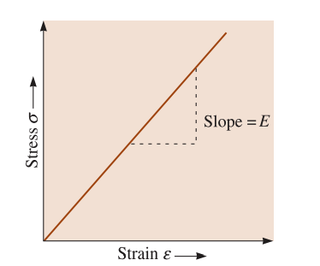

Figure 2 Tensile Stress vs Strain Curve (Elastic Material

* 1. **Tensile Tests**

*Source: Donald R. Askeland and Pradeep P. Fulay, Essentials of Materials Science and Engineering, 2nd ed., Cengage Learning (2008),p156*.*

*Figure 3 Non Linear Stress Strain Curve*

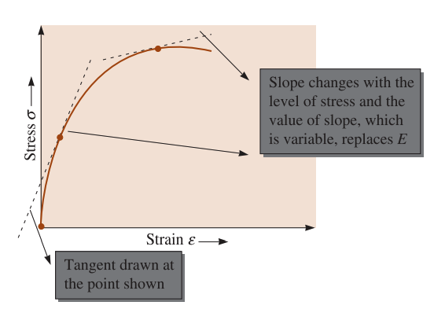

We use the tensile test to measure the resistance of a material to a slowly applied force or a static force. We use it to acquire the stress strain relationships for the given specimens.

The parameters used for this tensile test are Stress, σ and Strain, ε.

In a tensile test, the specimen is placed in the test machine and a load is applied (F). We use and extensometer to measure the change in the dimensions of the specimen. This gives us the change in length (Δ*l)*. We then use this and the initial length to calculate the strain.

Tensile tests are used to measure the Youngs Modulus, strength and ductility of a material. Tensile tests help us find the properties of materials and help us predict their behavior when under load.

1. **EXPERIMENTAL PROCEDURES**
   1. **Materials and Equipment**

For the tensile test, dog bone shaped 4340 steel was used. Digital Calipers were calibrated and used to accurately measure the diameter of the specimen. Instron Load frames running the Instron Bluehill control software was used as the load testing machine of choice. An extensometer was used to measure the change in length of the specimen.

* 1. **Experimental Preparation.**

Before testing, the dimensions of the specimen were accurately measured using digital calipers. The inner diameter was found to be 7.04mm and the outer diameter was found to be 12.61mm. The specimen was then placed in the load testing machine. The grip was tightened around the specimen. Once the specimen was setup in the load testing machine the extensometer was attached to the specimen.

* 1. **Testing Procedure**

The test started and continued until the specimen reached its failure load. At this point the specimen fractured and broke into two pieces. As the test progressed, the extension and the load were recorded every half second. This was done until the failure load was recorded. Once the test was completed, the specimen was removed and the fracture was observed. The final diameter of the specimen near the fracture was recorded using digital calipers. Finally, the stress strain curve was produced and studied.

1. **RESULTS**
   1. **Tensile Test**
   2. **Sfu**
   3. **Sf**
2. **REFERENCES**
3. "AISI 4340 Alloy Steel (UNS G43400)." AZoM.com. N.p., 07 Sept. 2012. Web. 31 Aug. 2016. http://www.azom.com/article.aspx?ArticleID=6772.
4. Askeland, Donald R., and Pradeep P. Fulay. Essentials of Materials Science and Engineering. Australia: Cengage Learning, (2009).
5. J.S. Popovics, L.J.
   1. **Djkdkd**
   2. **Djdjk**

.

|  |  |  |  |  |  |
| --- | --- | --- | --- | --- | --- |
| *Quantity* | *Symbol* | *Units* | *Lab* | *Expected* | *Percent Difference* |
| Young's Modulus | E | GPa | 220 | 190-210 | 4.76 |
| Ultimate Strength | σu | MPa | 761 | 745 | 2.15 |
| Fracture Strength | σf | MPa | 576 |  |  |